**Report**

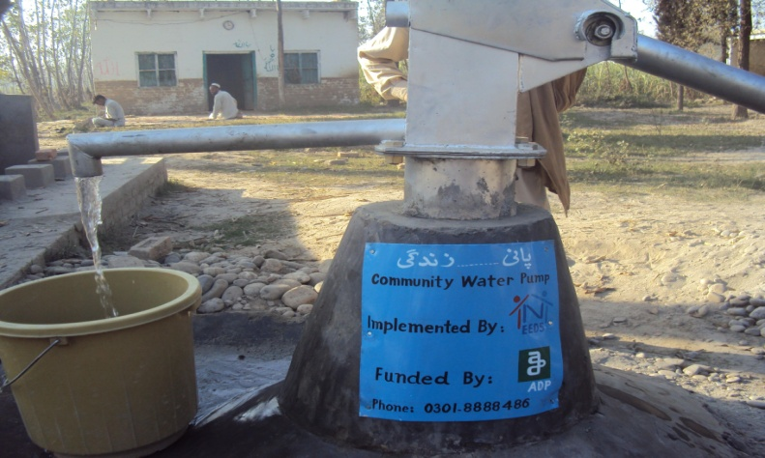

**Project Title**: Pure drinking water for flood affectees at district Charsadda

**Location**: 12 villages of UC Mirzadher, Tehsil Tangi, District Charsadda

**Number of beneficiaries**: 2095

**Implementing organoization**: Network for Education & Economic Development Services (NEEDS)

**Project cost**: Rs. 425,000

**Funded by**: Association for the Development of Pakistan (ADP)

**Objectives**: To increase access of flood affected people including men, women and children to safe drinking water.

**Outputs**:

* 12 community hand pumps installed and in operation
* 624 male, 634 female and 837 children are getting pure water for drinking and other daily needs
* 12 trained community groups keep management and maintenance of water hand pumps

**Activities**:

* Village selection
* Community mobilization
* Community groups formation
* Hand pumps installation
* Training of community groups on the repair and maintenance of hand pumps

**Description**:

Flood of July 2010 badly damaged 17 villages of district Charsadda, Pakistan and affected more than 300,000 people. These IDPs were placed in government schools and after their return to their homes the intensive need beside the other basic needs was pure drinking water because all the water sources have completely filled with sand and mud and the few exisiting water sources were highly polluted.

ADP has supported NEEDS organization for the installation of 12 community handpumps to fulfill the immediate need of pure drinking water. These water pumps installed in different villages affected by flood where approx 2300 people are benefiting from these hand pumps. These water pumps fulfilled the need for pure drinking water of the community people till they cleaned their traditional wells and other water sources. These water pumps have played a key role in the rehabilitation activities because as the pumps installed community people accelerated their house cleaning and started boundary walls construction to shift their families from IDP camps (schools) before re-opening of the schools.