[March 15, 2011]

Receipt
Network for Education & Economic Development Services (NEEDS) here by acknowledges the receipt of Rs 710,000 PKR (the “Grant”) from the Association for the Development of Pakistan Inc. (“ADP”).

Permissible Uses of the Grant
The Grant may only be used for non-profit purposes as defined by Section 501 of the United States Internal Revenue Code (“IRC”). The Grant is for the sole expressed purpose of funding the list of items identified in the attached budget (“Exhibit A”). All other uses or expenditures are expressly forbidden without ADP’s written consent.

Certification Regarding Terrorist Financing
Grantee agrees that release of the Grant by ADP depends upon the execution of the “Certification Regarding Terrorist Financing Implementing Executive Order 13224” (“Exhibit B”) by the Grantee.

Representations Made by Grantee
Grantee represents the following to ADP:
- Grantee is a non-profit entity and functions as a non-profit as defined by Section 501 of the US IRS.
- Neither Grantee nor any of its officers or directors are or have ever been engaged in funding, preaching, promoting, or in any way facilitating, directly or indirectly, any terrorist activity, violent political activity, or other activity that is illegal under any applicable law.
- The names of Grantee, its Board members, shareholders, members, officers, senior employees, and any organization through which Grantee conducts business do not appear, as of the effective date of this agreement, on any of the lists referenced in Exhibit C. Grantee does not have any other affiliation, including but not limited to the direct or indirect receipt or contribution of funds, with the persons or organizations named on said lists as of the effective date of this agreement.

ADP Liability
Grantee agrees to indemnify, defend, and hold ADP harmless from and against any losses, claims, liabilities, damages, costs, or expense of any kind (including reasonable attorneys’ fees) which arise out of, relate to, or are in any way connected with the Grant, any expenditure therefrom, and any acts of Grantee or any of its personnel.

Grantee Deliverables
Grantee shall deliver the following to ADP at the specified dates:

- Receipts for all expenditures over Rs. 1,000

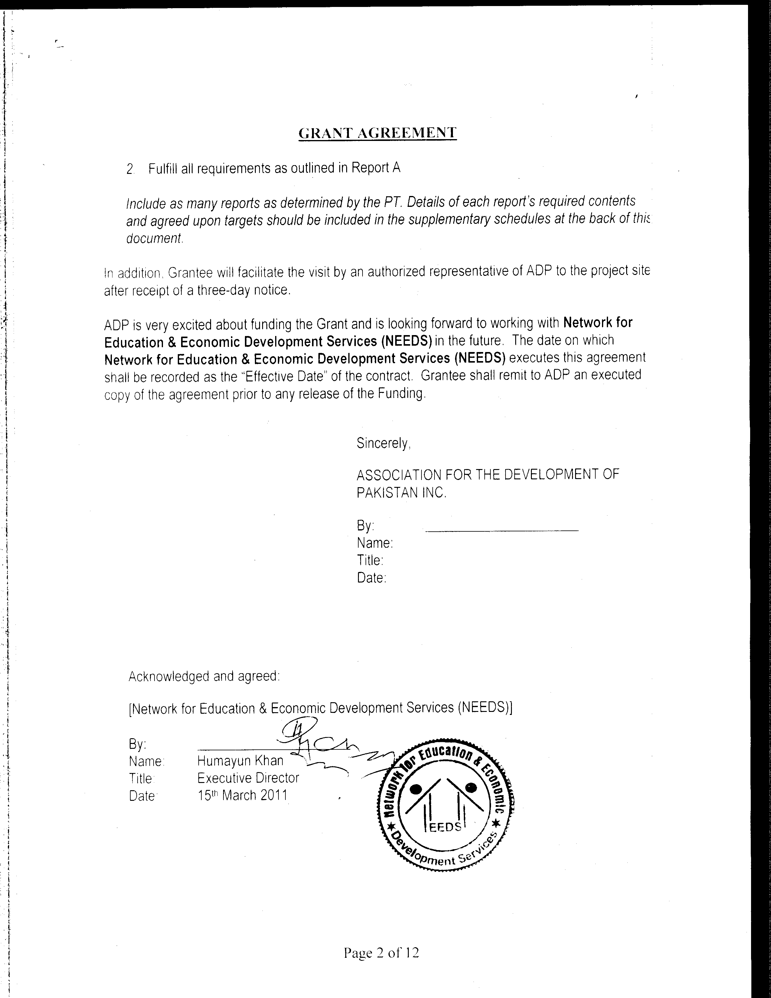

Exhibit A

Itemized project budget with estimated expense for each line item

Appendix

NEEDS BUDGET
 | Total | Phase 1: 4 Months | Phase 2: 4 - 8 Months | Phase 3: 8-12 Months
Loans | 500,000.00 | 150,000.00 | 150,000.00 | 200,000.00
Operating Budget
Project Coordinator Salary | 96,000.00 | 32,000.00 | 32,000.00 | 32,000.00
Micro Enterprise Officer | 72,000.00 | 24,000.00 | 24,000.00 | 24,000.00
Transportation | 42,000.00 | 14,000.00 | 14,000.00 | 14,000.00
Total Operating Budget | 210,000.00 | 70,000.00 | 70,000.00 | 70,000.00
Total Cost | 710,000.00 | 220,000.00 | 220,000.00 | 270,000.00

Exhibit B
CERTIFICATION REGARDING TERRORIST FINANCING
IMPLEMENTING EXECUTIVE ORDER 13224

By signing and submitting this application, [Network for Education & Economic Development Services] (“Grantee”) provides to the Association for the Development of Pakistan (“ADP”) the certification set out below:
- Grantee has not provided, and will take all reasonable steps to ensure that it does not and will not knowingly provide, material support or resources to any individual or entity that commits, attempts to commit, advocates, facilitates, or participates in terrorist acts, or has committed, attempted to commit, facilitated, or participated in terrorist acts.
- Specifically, in order to comply with its obligations under paragraph 1, Grantee will take the following steps:
  - Before providing any material support or resources to an individual or entity, Grantee will verify that the individual or entity does not appear:
    - on the master list of Specially Designated Nationals and Blocked Persons, which list is maintained by the U.S. Treasury’s Office of Foreign Assets Control (OFAC) and is available online at OFAC’s website (http://www.treas.gov/offices/eotffc/ofac/sdn/t11sdn.pdf), or
    - on any supplementary list of prohibited individuals or entities that may be provided by ADP to Grantee.
Grantee also will verify that the individual or entity has not been designated by the United Nations Security Council (UNSC) sanctions committee established under UNSC Resolution 1267 (1999) (the “1267 Committee”) [individuals and entities linked to the Taliban, Usama bin Laden, or the Al Qaida Organization]. To determine whether there has been a published designation of an individual or entity by the 1267 Committee, Grantee should refer to the consolidated list available online at the 1267 Committee’s website (http://www.un.org/sc/committees/1267/consolidatedlist.htm).
  - Before providing any material support or resources to an individual or entity, Grantee will consider all information about that individual or entity of which it is aware or that is available to the public.
  - Grantee will implement reasonable monitoring and oversight procedures to safeguard against assistance being diverted to support terrorist activity.

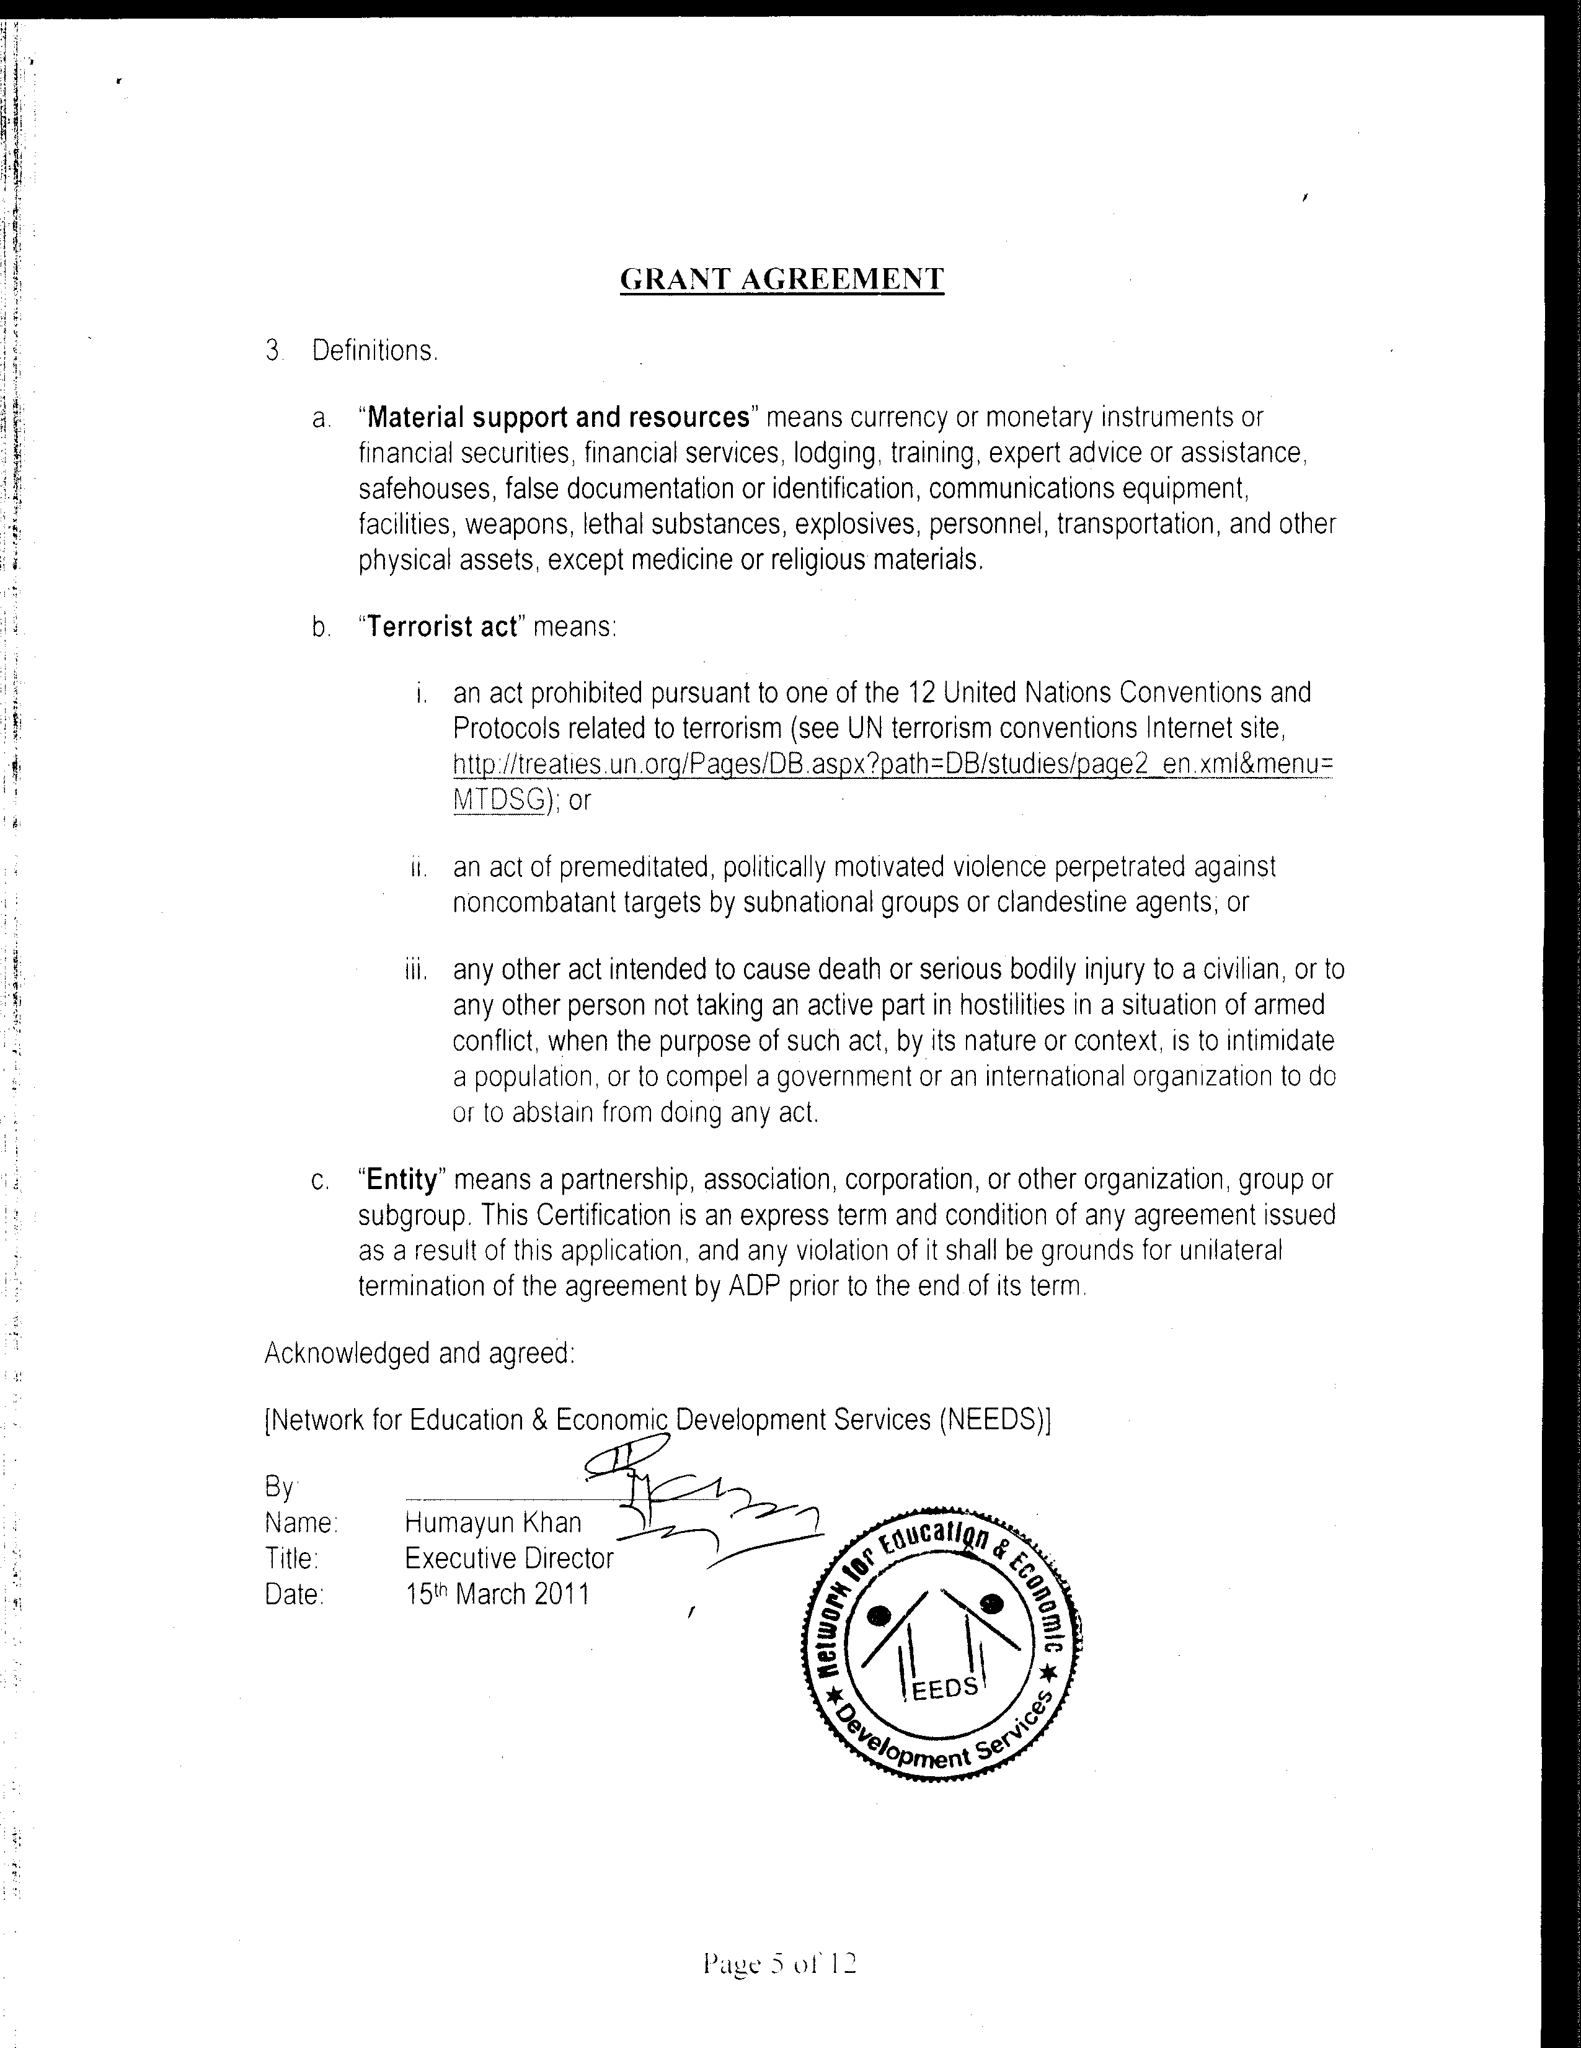

Exhibit C

Lists of persons or organizations deemed to be or suspected to be associated with terrorist acts.

- The Specially Designated Nationals list of the United States Department of Treasury’s Office of Foreign Assets Control (http://www.ustreas.gov/offices/enforcement/ofac/sdn/t11sdn.pdf).
- The Terrorist Exclusion List of the United States Department of Justice (http://www.state.gov/s/ct/rls/other/des/123086.htm).
- The Foreign Terrorist Organizations maintained by the United States Secretary of State (http://www.state.gov/s/ct/rls/other/des/123085.htm).
- Lists annexed to Executive Orders of the United States President (e.g., http://www.fas.org/irp/offdocs/eo/eo-13224.htm).
- The Consolidated List of the United Nations, established pursuant to Resolutions 1267 and 1390 (http://www.un.org/sc/committees/1267/consolist.shtml).
- The European Union List, established pursuant to EU Regulation 2580 (http://eur-lex.europa.eu/LexUriServ/site/en/oj/2007/l_169/l_16920070629en00690074.pdf).
Report A
NEEDS Microfinance Poultry Project
Implementation and Monitoring Plan

ADP Actions:
ADP will donate a total of Rs. 710,000 over 1 year to NEEDS for the microfinance poultry project.

NEEDS Actions:
NEEDS is responsible for disbursing Rs. 500,000 in loans to women headed households. The maximum loan size is Rs. 5000. The loans will be made in-kind (chickens and rooster) to enable the women to run a home-based poultry business. Eggs will be sold and chickens bred and sold. After the 1st year, NEEDS will continue to disburse the principal loan sum that is recovered from the first set of recipients and also any profits from the project. Loan funds provided by ADP must not be used for other purposes. If the model of disbursement changes at anytime, then ADP approval must be sought. Further, ADP reserves the right to remove support for the project at any time.

Documentation Requirements
For reporting purpose and for its own operation, NEEDS must keep its records up to date. ADP can request information at anytime. 3 forms are included with the monitoring plan that must be filled out regularly for record keeping.

1. Loan Report Form
- Up to date information on loan disbursement and repayment

2. Household Survey Form
- Information on income and expenses for every loan recipient that must be filled on each visit to the loan recipients. For the first 8 months, visits should be at least every two weeks to all households.

3. Monthly Household Master Form
- Aggregate of income and expenses for all loan recipients for each month

The information must be filled accurately. Besides satisfying ADPs reporting requirement, this information will help NEED expand their microfinance program from other donors.

Mandatory Training
Training must be provided by NEED to loan recipients before loan disbursement. Attendance at training sessions is mandatory and must be completed before disbursement. The training should include several components.

A: Raising poultry, sickness in chickens, hygiene etc.
B: Business aspects of running the business, keeping records, ensuring profits
C: Assistance with managing the loan, profits, and expansion. Additional training should be provided as needed.

Phase 1: 4 months

The plan is based on information provided by NEEDS, which states a disbursement schedule for the loans. NEEDS suggested they could disburse 32 loans in 3 months, however this was a pre-flood assessment. ADP has added 1-month grace period for loan disbursement

- ADP disburses Rs. 220,0000 for 30 loans to NEEDS. Each loan has a maximum value of Rs. 5000.

Deliverables from NEEDS: 4 months after completion

- Loan Report Form
- Monthly Household Master Form
- Sharing of training materials and evidence of participant attendance

Site Visit: ADP will conduct a site visit after the 4th month to evaluate the success of the project. Part of the trip will include visits to the homes of the loan recipients.

Conditions:
  - If less than 25 loans are disbursed in phase 1, the project will be re-evaluated on the basis that the interest of recipients for poultry-based microfinance is low in the area.
  - Training must be provided to every loan recipient as detailed earlier. Attending all training sessions is required before a loan can be disbursed
  - Note: 25 loans represent a minimum amount to be disbursed as a guide – the expectation on disbursement is 30, and ADP reserves the right to evaluate funding of the next tranche despite achievement of the minimum disbursement rate. This evaluation will be done on the phone with Humayun.
  - Project team will make a go-no go decision based on site visit and loan data

Phase 2: 4-8 months

- ADP will disburse Rs. 220,000 to NEEDS to provide 30 loans no more than a maximum of Rs. 5000 per loan.

Deliverables from NEEDS: 8 months after completion

- Loan Report Form
- Monthly Household Master Form for the period
- Evidence of participant attendance

Conditions:

  - If less than 25 loans are disbursed in phase 2, the project will be re-evaluated because potentially demand for the loan is saturated.
  - On time loan payment recovery rate of less than 70% will also lead to a re-evaluation of the project.
  - Continuing training and business support as described above must be provided to existing and new loan recipients. New loan recipients are required to attend training sessions before loan disbursement.
  - Note: 25 loans & 70% recovery rate represent a minimum amount to be disbursed and repaid as a guide – the expectation is disbursement of 30 and repayment of 100%, and ADP reserves the right to evaluate funding of the next tranche despite achievement of the minimum disbursement rate. This evaluation will be done on the phone with Humayun.
  - Project team will make a go-no go decision based on site visit and loan data

Phase 3: 8-12 Months

- ADP will disburse the balance of Rs. 270,000 to NEEDS for the balance of 40 loans.

Deliverables from NEEDS: 12 months after completion
- Loan Report Form for the year.
- Monthly Household Master Form
- Annual Financial Statement from NEEDS
- Expansion plan from NEEDS with profit and loan recovery. Profits and recovered loans are expected to be disbursed for more loans

Site Visit: ADP will conduct a site visit when and as needed

Conditions:

  - By the end of year 1, Rs. 500,000 should be disbursed in kind (chickens) to families with women headed households with a minimum of 100 loans made.
  - ADP may request loan funds not disbursed to be returned to ADP
  - Biannual financial statements must be provided by NEEDS beginning Year 2 of the project.
  - ADP will conduct annual site visits to the project.

Loan Report Form

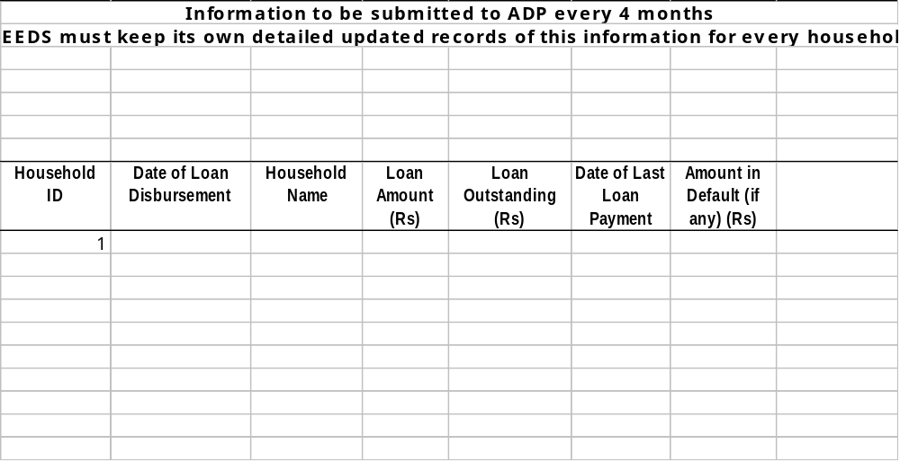

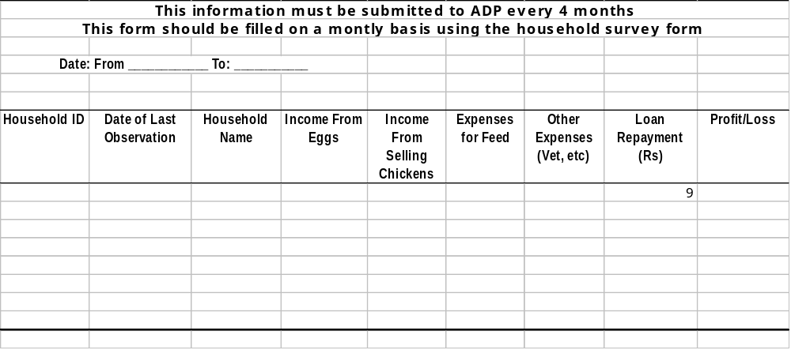Monthly Household Master Form



